Every program required 3 things
- Input
- Process
- Output

What is input?
Data or information given to the program is called input. This input given to the program using various sources (Keyboard, Scanner, OCR, Barcode Reader, files, database or programs)

What is Process?
Performing operations on input data is called process.

What is output?
Processed data is called output/result. This output is displayed on monitor, printer, file or database. The information given by program is called output.

print()
print() is in-built function in python, which is available in default module imported by python program (built-ins).

Note: to view content of any library use the following function
>>> dir(__builtins__)

What is function?
A function is small program within program.
A function is self contained block which contains set of instructions to perform operation
A function is named block
Python provides huge amount of built in functions available in different libraries.
Example: print(),max(),min(),sum(),input(),len(),….
A function takes input, process it and generate output
The input given to the function is called arguments.

Print function is having 5 parameters
- Values
- Sep
- End
- File
- Flush

Values: print function receives 0 or more values.
Example:
print(10)
print(100,200)
print(10,"naresh",5000.0)
print(1,2,3,4,5,6,7,8,9,10)
print()

Output
10
100 200
10 naresh 5000.0
1 2 3 4 5 6 7 8 9 10

Print function after printing values insert newline

Sep: when print function, prints more than on value it uses sep value. The default sep value used by print is space.

print(10,20,30)
print(10,20,30,sep=",")
print(10,20,30,40,50,sep="*")
print(10,20,30,sep="\t")
print(10,20,30,sep="\n")
print(1,"naresh","python",5000.0,sep=":")
print("rollno","name","course",sep="\t")
print(10,20,30,40,50)
print(10,20,30,40,50,sep="nit")

Output
10 20 30
10,20,30
10*20*30*40*50
10 20 30
10
20
30
1:naresh:python:5000.0
rollno name course
10 20 30 40 50
10nit20nit30nit40nit50

Example:
a=10
b=20
c=30
d=40
print(a,b,c,d)
print(a,b,c,d,sep="\t")
print(a,b,c,d,sep="\n")
print(a,sep=",")

Output
10 20 30 40
10 20 30 40
10
20
30
40
10

end
print function after printing all the values it print end value
the default of end is \n

Example:
print(10,20)
print("Python")
print(100,200,end='.')
print("JAVA")
print("ORACLE",end=' ')
print("MONGODB")

Output
10 20
Python
100 200.JAVA
ORACLE MONGODB

file:
print function receives all the values and print or write inside a file called stdout(standard output/console)
this parameter can be used to inside user defined file to store or save output permanently

flush:
print function print data inside buffer. In order to move data from buffer to file the value of flush=True.

Example:
fobj=open("output.txt","w")
print(10,20,30,40,50)
print(100,200,300,400,500,file=fobj)
print(1000,2000,3000,4000,5000,file=fobj,flush=True)

Output
10 20 30 40 50
Remaining print statements output is inside output.txt file

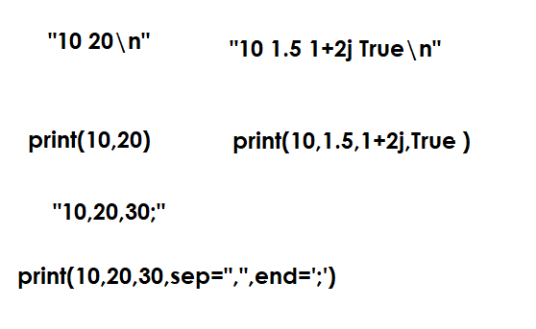
s

